|  |  |
| --- | --- |
| **TITRE PROCÉDURE** | |
| installation of a client workstation | |
|  |  |
| Auteur : Loïc | Date de publication : 02/12/2019 |

|  |  |
| --- | --- |
| Objectif | installation of a client station with data backup |
| Ressources | Serveur, Windows serveur 2016, client post |
| Outils | functional MDT and WDS service |
| URL |  |
| Autres |  |

Table des matières

TITRE PROCÉDURE 3

1. Chapitre 1 3

2. Chapitre 2 3

A. Partie 1 3

B. Partie 2 3

# Installation

## Installation

### Starting a machine in PXE

Make sure before you start your machine that it will start well on the network by changing the priority orders in the BIOS.

When the client machine starts, we can see that it is contacting our WDS server correctly:

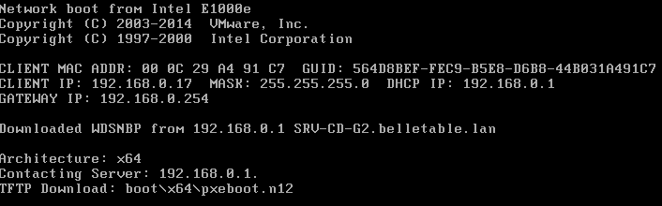

Just tap F12 to initiate installation from the network. The first page of the configuration software is launched.

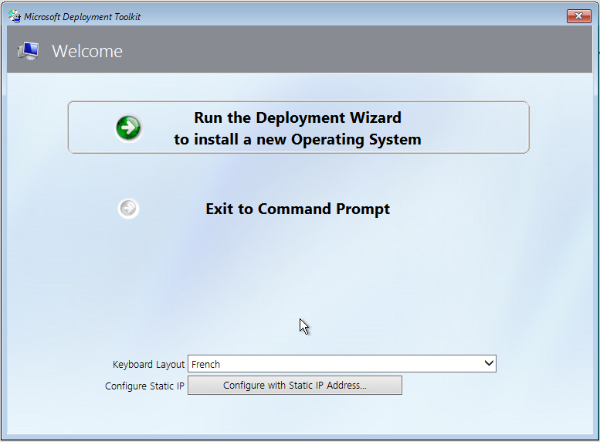

The application specific to the station to be installed is directly selected.

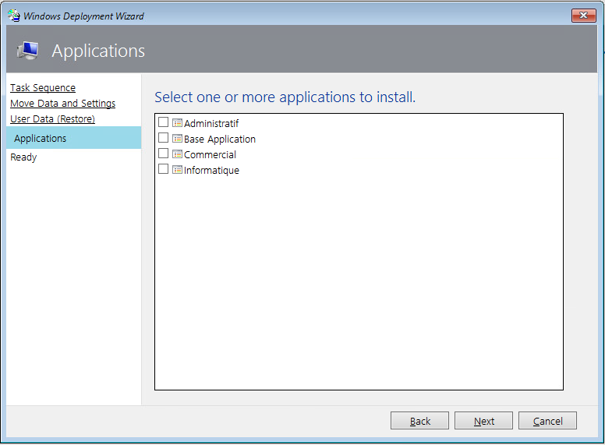

The installation is launched on the last window. During this process, the computer restarts to finalize it. Once our custom system is installed, a window will appear, informing us if all the steps of the deployment have been completed.

